**#] Become familiar with DHTML**

1. **Introduction to DHTML**

<https://www.geeksforgeeks.org/dhtml-introduction/>

1. **Understand the basic of Javascript**

<https://developer.mozilla.org/en-US/docs/Learn/Getting_started_with_the_web/JavaScript_basics> (very useful)

1. **Learn more on Variables**

<https://www.w3schools.com/js/js_variables.asp>

<https://www.w3schools.com/js/js_output.asp>

1. **Become familiar with data types**

<https://www.w3schools.com/js/js_datatypes.asp>

1. **Get familiar with operator**

<https://www.w3schools.com/js/js_operators.asp>

1. **Learn more on function**

<https://developer.mozilla.org/en-US/docs/Web/JavaScript/Reference/Functions/Default_parameters>

<https://www.w3schools.com/js/js_functions.asp>

1. **Introduction to Regular Expression**

<https://www.w3schools.com/jsref/jsref_obj_regexp.asp>

1. **Understand more about math function**

<https://www.w3schools.com/js/js_math.asp>

1. **Get familiar with Form Validation**

<https://www.w3schools.com/js/js_validation.asp>

**#] Bugs related to Reset and Function Execution**

1. [**https://docs.google.com/spreadsheets/d/1d1cOcEn-IVxRM4f79JsI1OAhwZJNLikfxxxZ5lihwSQ/edit?usp=sharing**](https://docs.google.com/spreadsheets/d/1d1cOcEn-IVxRM4f79JsI1OAhwZJNLikfxxxZ5lihwSQ/edit?usp=sharing)

[**https://forms.gle/7uCDkNNnf2ZvKqHU7**](https://forms.gle/7uCDkNNnf2ZvKqHU7)

[**https://docs.google.com/spreadsheets/d/1d1cOcEn-IVxRM4f79JsI1OAhwZJNLikfxxxZ5lihwSQ/edit?usp=sharing**](https://docs.google.com/spreadsheets/d/1d1cOcEn-IVxRM4f79JsI1OAhwZJNLikfxxxZ5lihwSQ/edit?usp=sharing)

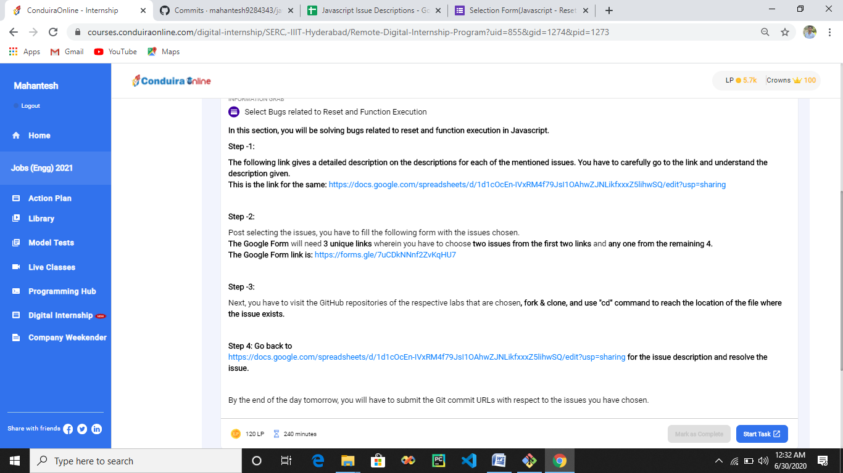

**#] Master the components of Advance javascript**

1. **Get introduction to Document objects model**

<https://www.w3schools.com/js/js_htmldom.asp>

1. **Learn more about Events**

<https://www.w3schools.com/js/js_events.asp>

1. **Understand more about Control flows**

<https://developer.mozilla.org/en-US/docs/Web/JavaScript/Guide/Control_flow_and_error_handling>

1. **Learn Error and Exception Handling**

<https://www.w3schools.com/js/js_errors.asp>

1. **Become familiar with String and Data structures**

<https://www.w3schools.com/js/js_strings.asp>

**#] Get started with Bootstrap**

1. **Introduction to Bootstrap**

<https://www.geeksforgeeks.org/bootstrap-4-introduction/>

<https://getbootstrap.com/docs/4.0/getting-started/introduction/>

1. **JS libraries and framework**

<https://api.jquery.com/hide/>

**#] Further your understanding in JQuery library**

1. **Understand about JS libraries and Framework**

<https://www.journaldev.com/4947/jquery-double-click>

<https://www.geeksforgeeks.org/jquery-toggle-method/>

<https://www.w3schools.com/jquery/jquery_ajax_get_post.asp>

**Form Issues**

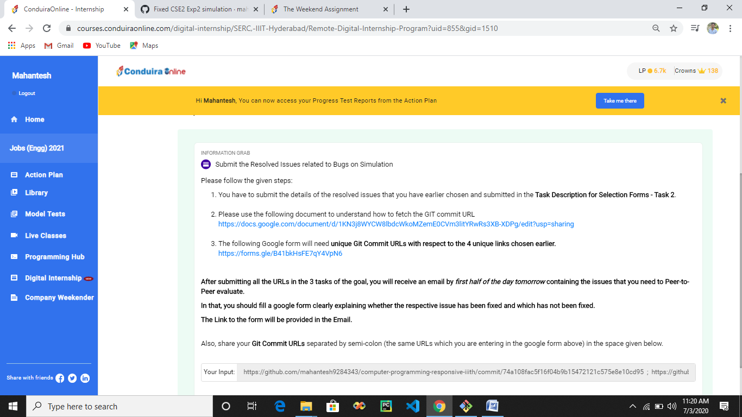

**Assignment 2**

